**Topic:** Are Ear Infections Contagious in 2022 – Vigoursoul

**Focus keyword:** Are Ear Infections Contagious

**Meta Title:** Are Ear Infections Contagious in 2022 – Vigoursoul

**Meta Description:** "Are ear infections contagious are frequently caused by communicable bacterial or viral diseases, such as the common cold or flu.



An ear infection is usually caused by a bacterial or viral infection that affects the middle ear. Ear discomfort is the most typical sign of an ear infection. Although adults can have ear infections, children are more likely to get them. Ear infections frequently resolve ontheir own. In moreextreme situations, they may require medical attention. Ear infections can occur during or after a cold or a communicable infection. As a result, some individuals wonder if ear infections are communicable. Continue reading to discover about the most frequent causesof ear infections and how to avoid them.

**Table of content:**

**Are ear infections contagious?**

Ear infections are not spreadable. However, bacterial and viral infections that cause ear infections can be passed from person to person. Ear infections are classified into three types:

* **Infection of the external ear.** This is popularly known as "swimmer's ear."
* **Labyrinthitis.** This is an infection-related inflammation of the inner ear.
* **Infection in the middle ear**. This is also referred to as otitis media. It is the most frequent kind of ear infection in youngsters.

An ear infection is usually caused by a bacterial or viral infection that affects the middle ear. Ear discomfort is the most typical sign of an ear infection. Although adults can have ear infections, childrenare more likely to get them. Ear infections frequently resolve on their own. In more extreme situations, they may require medical attention. Ear infections can occur during or after a cold or a communicable infection. As a result, some individuals wonder if ear infections are communicable. Continue reading to discover about the most frequent causes of ear infections and how to avoid them.

**Are Ear Infections Contagious in Adults?**

Ear infections on their own are not communicable. However, organisms that raise your chance of acquiring an ear infection, such as those from the common cold and flu, can be infectious. You may lower your chance of having an ear infection by adopting easy, healthful practices.

**Are Ear Infections Contagious in Babies?**

Children's ear infections are quite prevalent. However, there are steps parents may do to limit the amount of ear infections their children may get. Ear infections are not communicable or passed from person to person, but the colds that cause them are.

**How long are you Contagious with Ear Infection?**

Most ear infections resolve within three days, however symptoms might continue up to a week. If you or your kid has a fever or does not feel well enough to engage in typical activities, try to stay at home and avoid contact with others until you feel better.

**Are Sinus and Ear Infections Contagious?**

Bacterial and allergy sinus infections are not infectious. Bacterial sinus infections arise when the nasal passages of a person are clogged for a lengthy period of time, allowing germs to thrive.

**Are Bacterial ear Infections Contagious?**

Ear infections are not communicable or passed from person to person, but the colds that cause them are. Colds are transferred when germs from the nose or mouth are expelled when coughing or sneezing. Anything that will help prevent germ spread can help reduce ear infections.

**Are Double Ear Infections Contagious?**

Ear infections are not spreadable. However, respiratory infections that may occur as a result of an ear infection are. Adenoids, which are tissue pads at the back of the nose, can also contribute to a double ear infection, particularly in infants.

**Are Fungal ear Infections Contagious?**

Is it possible to spread a fungal ear infection? As a result, fungal ear infections are not communicable. However, the fungus that causes ear infections can be passed from person to person when swimming in contaminated water.

**Symptoms of an ear infection:**

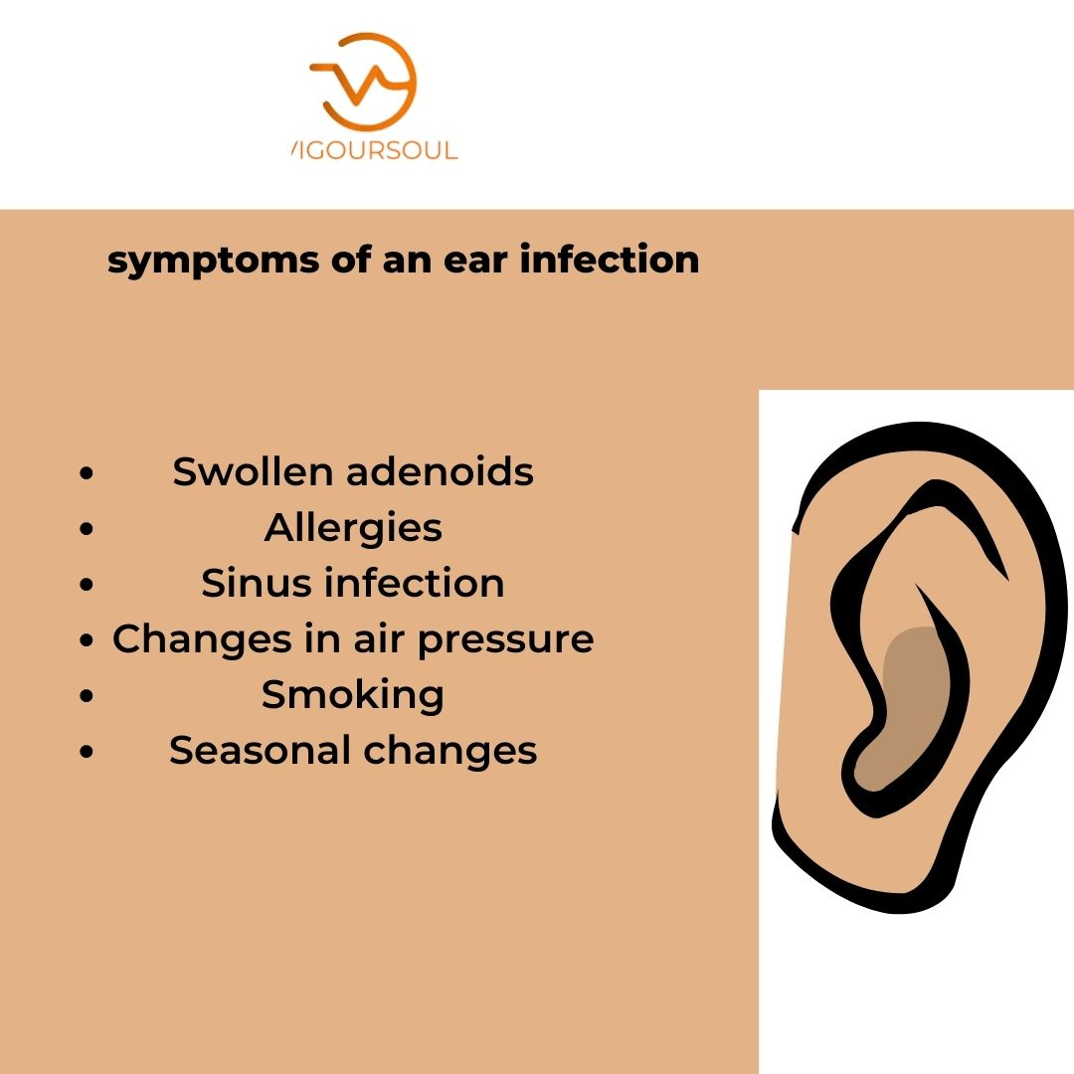

* Swollen [adenoids](https://www.healthline.com/health/enlarged-adenoids)
* Allergies
* Sinus [infection](https://www.healthline.com/health/cold-flu/sinus-infection-symptoms)
* Changes in air pressure
* Smoking
* Seasonal changes

**Treating an ear infection:**

* Many ear infections resolve on their own without the need for medical attention. Over the course of a week or two, your doctor may want to keep an eye on your symptoms for indications of improvement.
* Doctors frequently advocate a watch-and-wait approach for younger children with minor ear ache, with symptoms monitored for no more than 48 hours.
* If your symptoms do not improve, your doctor may prescribe antibiotics or ear drops (for external ear infections). Surgery to remove excess fluid from the middle ear may be necessary in more severe or persistent instances.

**Tips for prevention:**

Ear infections are not spreadable. However, you may avoid transferring bacteria that can cause an ear infection by taking the following basic precautions:

* Thoroughly wash your hands.
* Cover your lips while coughing and your nose when sneezing.
* If you or someone else is sick, don't share utensils.
* Avoid smoking or being exposed to secondhand smoke.
* Obtain flu and other virus vaccination.
* Stay at home if you have a fever and for at least 24 hours after it go away without medicine.

**FAQS**

**Where are ear infections most common?**

They are the most frequent ear infection, particularly in youngsters. Middle ear infections often occur when the Eustachian tubes, which link your ears to your throat, get enlarged as a result of a cold, flu, or allergies.

**What is the best antibiotic for an ear infection?**

Amoxicillin is one of the most regularly recommended medicines for ear infections. However, due to its regular and frequently unneeded usage, certain germs are growing resistant to it. Ciprofloxacin is another frequent antibiotic used to treat bacterial ear infections.

**What is the fastest way to get rid of an ear infection in adults?**

Antibiotics are a type of medication that is recommended by your doctor. If you have a bacterial ear infection, you will most certainly require antibiotics. They are the most effective method of swiftly eliminating a bacterial infection and preventing it from spreading to other regions of the body.

**Do you need antibiotics for ear infection?**

Antibiotics are not always required for middle ear infections. However, serious middle ear infections or infections that persist more than 2-3 days require antibiotics to be administered immediately. If you have a minor middle ear infection, your doctor may advise you to wait it out or to take antibiotics later.

**Conclusion:**

Is an Ear Infection Spreadable? While ear infections themselves are not communicable, the germs and viruses that cause them are. As a result, you might get the virus or bacterium that your loved one is harboring.

For More Blogs:<https://vigoursoul.com/>

[Stress on Mental Health in 2022 | Vigoursoul](https://vigoursoul.com/health-and-fitness/)

[Health and Fitness | Vigoursoul](https://vigoursoul.com/health-and-fitness/)